Elk Haven Equestrian Center  201 Elk Haven Rd  Cle Elum, WA  elkhavenequestrian.com |  |  |  |  | 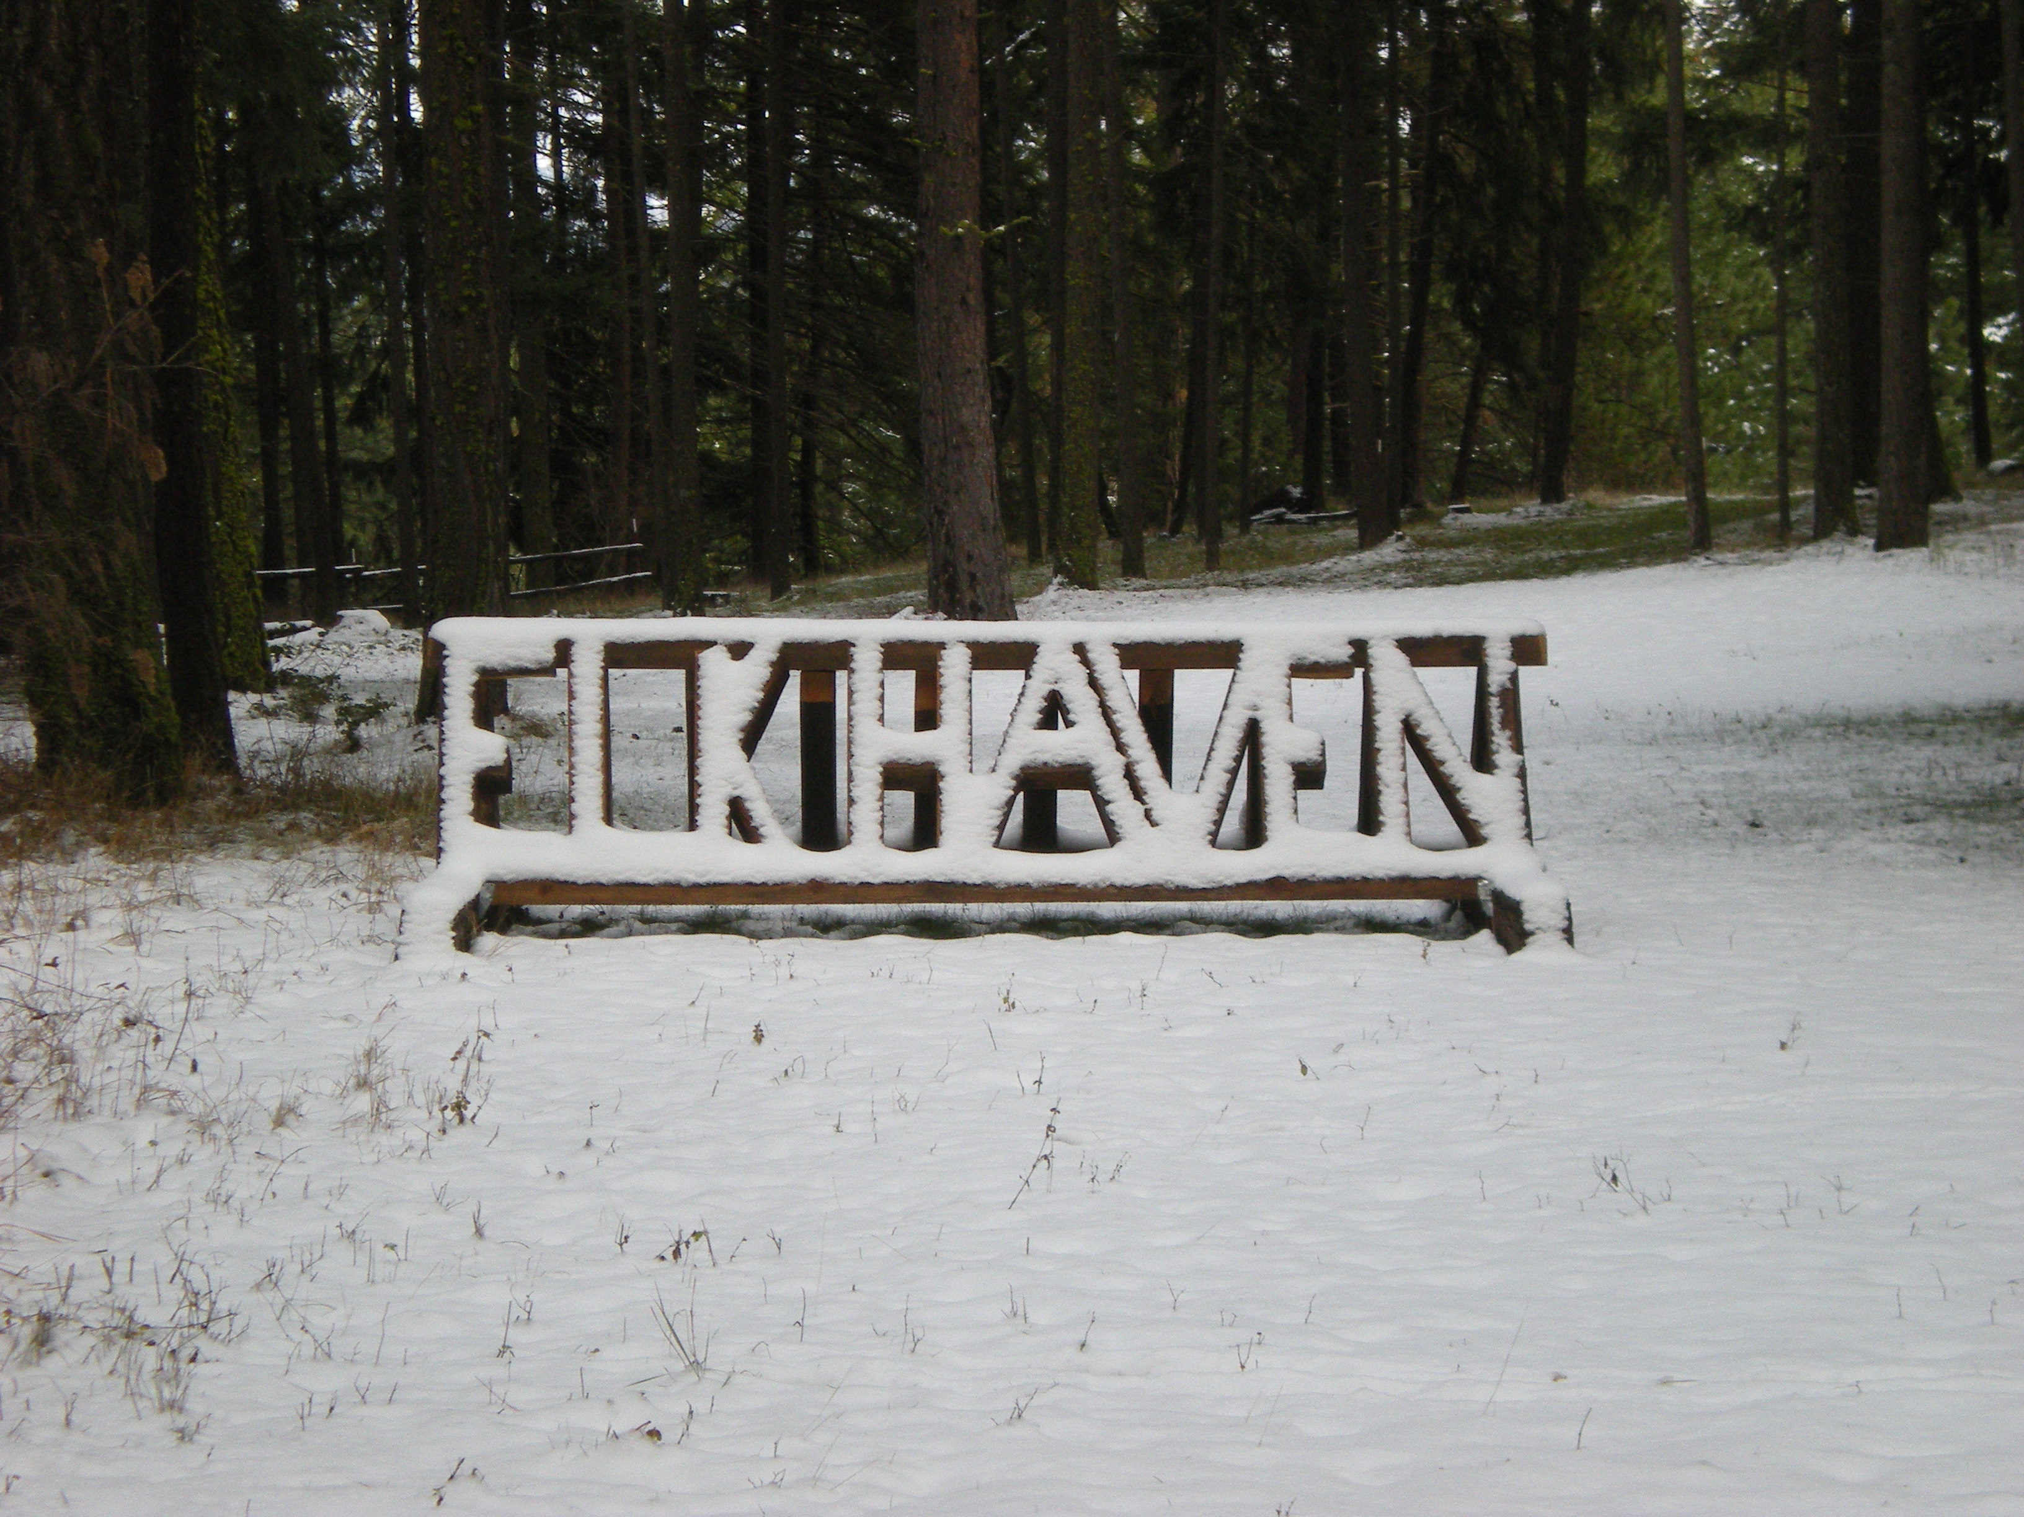
Owner’s Informational Sheet |  |  |  |  | Date |  |  |  |  |  | Updated
Owner’s Name |  |  |  |  | E-mail
Address: |  |  |  | City: |  |  |  | State: |  |  |  | Zip:
Home Phone |  |  |  | Work Phone |  |  |  | Cell Phone
Emergency Contact (If we cannot reach you at the above numbers): |  |  |  | Name |  |  |  |  |  | Phone #
Owner agrees to notify Manager of any and all change of address, emergency telephone numbers, itineraries or other information reasonably necessary to contact Owner in the event of an emergency.
Horse’s Name |  |  |  |  | Barn Name
Breed |  |  |  |  |  |  | Color
Distinguishing Marks/Brands
Picture: (Will be taken upon arrival and added electronically to file) |  |  | Weight upon arrival |  |  |  |  |  | Desired Weight
Medical History
Veterinarian: |  |  |  |  | Location: |  |  |  |  |  | Contact #
Proof of Immunizations: |  |  | Tetnaus (m/d/yy) |  |  |  |  |  | Rabies (m/d/yy)
West Nile virus |  |  | Flu/Rhino |  |  |  |  |  | Strangles (optional)
Farrier: |  |  |  |  | Contact #
Insured? | No
 | Yes | Company |  |  |  | Phone |  |  |  |  | Policy #
Vices/Habits (cribbing, biting, etc)

Other Pertinent Information

Horse is NOT a surgical candidate
Owner desires surgical care if recommended by a veterinarian
Owner initials _______

Elk Haven Equestrian Center
elkhavenequestrian.com
PLEASE read carefully before signing, the managers/stable owners do not guarantee your safety or that of your horses. Riding includes all handling of the horse(s), whether from the ground or mounted.
Boarding Agreement and Liability Release
By this agreement, made and entered this day of 20 , by and between Jim Miller and Ginni Erion, who reside at Elk Haven Equestrian Center, herein referred to as “Managers” and/or “STABLE Owner’s” and herein referred as “Owners/ Boarders”.
Fees: Owners agrees to pay the sum of $ per month for board for all services described below. Monthly board is to be paid in advance and is due on the first of the month.
Late Fee of ten dollars ($10) per day is charged for payments received after the 10th of the month.
Boarding Specifics: Elk Haven offers 2 options for boarding, please mark your choice:
1) Dry lot under trees ($250 per month)
2) Run-in with dry lot and irrigated pasture, semi private tack room. ($350 per month)
EHEC will feed total of 25# of Elk Haven hay in two feedings
Additional fee per 5 # hay ($15.00 per month for additional 5# per day)
EHEC will feed Owner’s provided grain | Included
EHEC will worm with Owner’s provided product | Included
EHEC will feed Owner’s supplements fed ONLY as provided | Included
Daily turnout into irrigated pasture weather permitting (Upper Facility) | Included
Cleaning of stall and dry lot | Included
Handling for Emergency care | Included
EHEC will allow access to trails, 3 arenas, cross-county courses-  please read rules regarding use | Included
Have 12x12 and 24x12 stalls available for emergencies or foaling
Horse requires closed stall (additional Fee $5.00 per day)
Handling for Vet/Farrier/Hoof trimmer (NON-EMERGENCY)
$10.00 Pre-arranged up to 45 minutes-

EHEC doctoring for short-term medical care (spray and/or salve) (4 times/month or per incident)  Doctoring for long-term medical care beyond 4 times per month/incident.  $5.00 per occurrence if applying spray, salve, injection, or oral medication.  $20.00 per occurrence if care includes bandage change.  If physical therapy is required, then $10.00 per 15 minutes | Included
Storage of trailer – very limited due to farming and irrigation | Included
Horses must have halter and lead left for facility use. Blankets/sheets may also be left. Please mark your tack with your name.
Initials:

Owner ____
Elk Haven Equestrian Center
elkhavenequestrian.com
Boarded Horse Health Warranty:
Each horse to be boarded shall enter the premises free from transmissible diseases, and must be effectively wormed, and current on immunizations for tetanus, rabies, strangles (optional), West Nile virus, and a flu/rhino. Owner must present the following up-to-date document to the Managers prior to the entry of horse onto this stable’s property: Worming and Immunization Record and proof of current vaccinations. The stable requires that all boarders agree to participate in a regular worming program.

Owner Acceptance of Responsibility:
During the time that the horse(s) are being boarded, the horse(s) shall be in the custody of the Manager. Owner has inspected the Manager’s premises and/or has in some other way satisfied himself that the conditions of the premises and the facilities will provide an adequate and reasonable level of safety for Owner’s horse(s). Owner further agrees to be responsible for any and all damages, injuries, loss of life caused by or to the animals while in the control of the Owner, Owner’s family members, invitees or other handlers or agents appointed by them, and also for any acts of the horse(s) caused by vices or dangerous behavior not disclosed to the manager by Owner. Owner is also responsible for accidents, injuries, and loss of life sustained by Owner, owner’s family members, invitees and agents caused by or in relation to the owner’s horse(s). NO BOARDER’S DOGS/PETS ARE ALLOWED ON PROPERTY FOR SAFETY OF HORSES AND RIDERS/Boarders.

Lien Against Boarded Animal:
The owner hereby grants a possessory lien against the boarded animal(s) to this stable for the value of all unpaid charges resulting from boarding and rendering any services to the animal(s). Should such charge go unpaid this stable shall be entitled to exercise the right to enforce said lien according to the laws of Washington State.

Direct Loss to Personal Property Warning:
Owner is herby warned that direct loss or damage, theft, injury or disappearance of owner’s horse(s), tack, equipment, or other property is not covered by Manager’s insurance and Manager shall not be liable for the Owner’s horses, tack, equipment, or other property. All reasonable precautions will be made to prevent loss of Owner’s property. Owner may store tack and equipment on the premises in provided tack rooms. Tack rooms are shared and will be locked providing limited access.

Initials:
Owner _______

Elk Haven Equestrian Center
elkhavenequestrian.com

Emergency Care:
Manager agrees to attempt to contact Owner should Manager determine veterinary treatment is needed for said horse(s), but, if Manager is unable to contact Owner, Manager is then authorized to secure emergency veterinary, and farrier care required for the health and well being of said horse(s). Owner shall pay all costs of such care incurred within fifteen (15) days from the date Owner receives notice thereof, or Manager is authorized, as Owner’s agent, to arrange direct billing to Owner. Manager shall assume that Owner desires surgical care if recommended by a veterinarian in the event of colic, or other life-threatening illness, unless manager is instructed herein by Owner or on Owner’s Informational Sheets, that the horse is NOT a surgical candidate.
Owner agrees to notify Manager of any and all change of address, emergency telephone numbers, itineraries or other information reasonably necessary to contact Owner in the event of an emergency.

Notice of Termination:
Owner agrees that (30) thirty-day notice in writing shall be given to Manager as to the termination of this agreement.

Rate Changes:
Should such a change be required, the Stable will provide the owners no less than (30) thirty days written notice.

Mediation/Arbitration:
In the event of any dispute or disagreement relating in any manner whatsoever to this Agreement the partied agree and consent to engage in mediation in a good faith effort to resolve the dispute amicably before either party resorts to court actions.

Inherent Risks and nature of the Horse Warning
Horseback riding, handling, and horse driving are classified as rugged adventure recreational sport activity, and there are numerous obvious and non-obvious inherent risks always present in such activity despite all safety precautions. The undersigned acknowledges there are inherent risks associated with equine activities even with what is described as a completely safe horse. The inherent risks include, but are not limited to; stopping short, changing direction or speed at will; shifting its weight from side to side, bucking, rearing, kicking, biting, running from danger, shying, falling, and/or stepping on human; that may result in an injury, harm or death to persons on or around them or to animal itself or to other animals around them. The unpredictability of equine’s reaction to such things as: sounds, sudden movement, and unfamiliar objects, persons or other animals and certain hazards such as: surface and subsurface conditions; collisions with other animals, and the limited availability of emergency medical care, and the potential of a participant to act in a negligent manner that may contribute to injury to the participant or others, such as failing to maintain control over the animal, all contribute to the inherent risks one assumes when around/riding horses.

Initials:
Owner _______

Elk Haven Equestrian Center
elkhavenequestrian.com
Release of Liability
In consideration on this stable undertaking the board and relate services under the terms set forth herein, I, the undersigned OWNER, do agree to hold harmless and release this stable, its owners, agents, employees, officers, members, premises owners, insurers, and affiliated organizations from legal liability due to this stable’s ordinary negligence; and I do further agree that except in the event of this stable’s and it’s associates as stated above in this clause, for any economic and non-economic losses due to bodily injury, death, property damage, and injury to or loss by death of the boarded animal(s) and /or sustained by me and/or my minor child or legal ward in relation to the premises and operation this stable.

Riding Helmet Warning
Owner is hereby warned by this stable that all horse handlers and riders should purchase and wear properly fitted and secured protective headgear (equestrian riding helmet), and that wearing of such headgear while mounted, riding, dismounting and being around horses, may prevent or reduce severity of some head injuries and may even prevent death happening as a result of a fall or other occurrence. PROCTIVE EQUESTRIAN RIDING HELMETS REQUIRED WHILE GOING OVER FENCES (ANY OBSTICALS RAISED ABOVE THE GROUND LEVEL).
HELMETS ARE REQUIRED FOR ALL MINOR AGED RIDERS regardless of discipline.

Managers Right to Refuse Services
Manager reserves the right to refuse the continuation of boarding services of any horses for any reason, to include by not limited to: animal’s poor health or unsoundness; dangerous propensities, habits and/or vices which Manager may not be equipped or capable to handle; owners refusal to obey stable rules or to cooperate with manager on reasonable requests relative to the management, boarding, welfare and safety of animals and people on premises; and, also in such event Manager shall give the Owner 7(seven) day written notice to remove horses from premises. After all fees have been paid in full this agreement is concluded.

Entire Agreement
This contract represents the entire agreement between parties. No other agreements, promises, or representations, verbal or implied, are included herein unless specifically stated in this written agreement. This contract is made and entered into in the state of Washington, and shall be enforced and interpreted in accordance with the laws of Washington State.
WARNING
Under the REV. Code of Washington (ARCW) s4.34.530 1994 Equine Inherent Risk Law, your presence on these grounds indicate that you have accepted the limits of liability resulting from inherent risks of equine activities

Initials:
Owner _______

Elk Haven Equestrian Center
elkhavenequestrian.com
SIGNER STATEMENT OF AWARENESS
I/WE THE UNDERSIGNED, HAVE READ AND DO UNDERSTAND THE FORGOING AGREEMENT, WARNINGS, ASSUMPTIONS OF RISK AND RELEASE AGREEMENT. I/WE FURTHER ATTEST THAT ALL STATED FACTS ARE TRUE AND ACCURATE AND HAVE IDICATED SUCH BY INITIALING EACH PAGE.

Signature or Owner/rider #1 | Date
Signature of Owner/rider #2 | Date
Signature of Manager | Date
Desired date of arrival: (needing accommodations by…)

Picture of horse to be added:

